# 

| Cybersecurity |
| --- |
| Penetration Test Report Template |

MegaCorpOne

Penetration Test Report

**CyberGrunt, LLC**

# 

## Confidentiality Statement

This document contains confidential and privileged information from MegaCorpOne Inc. (henceforth known as MegaCorpOne). The information contained in this document is confidential and may constitute inside or non-public information under international, federal, or state laws. Unauthorized forwarding, printing, copying, distribution, or use of such information is strictly prohibited and may be unlawful. If you are not the intended recipient, be aware that any disclosure, copying, or distribution of this document or its parts is prohibited.

## Table of Contents

Confidentiality Statement 2

Contact Information 4

Document History 4

Introduction 5

Assessment Objective 5

Penetration Testing Methodology 6

Reconnaissance 6

Identification of Vulnerabilities and Services 6

Vulnerability Exploitation 6

Reporting 6

Scope 7

Executive Summary of Findings 8

Grading Methodology 8

Summary of Strengths 9

Summary of Weaknesses 9

Executive Summary Narrative 10

Summary Vulnerability Overview 11

Vulnerability Findings 12

MITRE ATT&CK Navigator Map 13

# 

## Contact Information

| **Company Name** | CyberGrunt, LLC |
| --- | --- |
| **Contact Name** | Charles Wallace |
| **Contact Title** | Penetration Tester |
| **Contact Phone** | 309.266.2437 |
| **Contact Email** | charles.wallace@cybergrunt.com |

## Document History

| **Version** | **Date** | **Author(s)** | **Comments** |
| --- | --- | --- | --- |
| 001 | 04/19/2023 | Charles Wallace | First Draft |
| 002 | 04/28/2023 | Charles Wallace | Initial Review |
| 003 | 05/03/2023 | Charles Wallace | Final Review |
|  |  |  |  |

# 

## Introduction

In accordance with MegaCorpOne’s policies, CyberGrunt, LLC (henceforth known as CG) conducts external and internal penetration tests of its networks and systems throughout the year. The purpose of this engagement was to assess the networks’ and systems’ security and identify potential security flaws by utilizing industry-accepted testing methodology and best practices. The project was conducted on a number of systems on MegaCorpOne’s network segments by CG during April 2023.

For the testing, CG focused on the following:

* Attempting to determine what system-level vulnerabilities could be discovered and exploited with no prior knowledge of the environment or notification to administrators.
* Attempting to exploit vulnerabilities found and access confidential information that may be stored on systems.
* Documenting and reporting on all findings.

All tests took into consideration the actual business processes implemented by the systems and their potential threats; therefore, the results of this assessment reflect a realistic picture of the actual exposure levels to online hackers. This document contains the results of that assessment.

### Assessment Objective

The primary goal of this assessment was to provide an analysis of security flaws present in MegaCorpOne’s web applications, networks, and systems. This assessment was conducted to identify exploitable vulnerabilities and provide actionable recommendations on how to remediate the vulnerabilities to provide a greater level of security for the environment.

CG used its proven vulnerability testing methodology to assess all relevant web applications, networks, and systems in scope.

MegaCorpOne has outlined the following objectives:

Table 1: Defined Objectives

| **Objective** |
| --- |
| Find and exfiltrate any sensitive information within the domain. |
| Escalate privileges to domain administrator. |
| Compromise at least two machines. |

# 

## Penetration Testing Methodology

### Reconnaissance

CG begins assessments by checking for any passive (open source) data that may assist the assessors with their tasks. If internal, the assessment team will perform active recon using tools such as Nmap and Bloodhound.

### Identification of Vulnerabilities and Services

CG uses custom, private, and public tools such as Metasploit, hashcat, and Nmap to gain perspective of the network security from a hacker’s point of view. These methods provide MegaCorpOne with an understanding of the risks that threaten its information, and also the strengths and weaknesses of the current controls protecting those systems. The results were achieved by mapping the network architecture, identifying hosts and services, enumerating network and system-level vulnerabilities, attempting to discover unexpected hosts within the environment, and eliminating false positives that might have arisen from scanning.

### Vulnerability Exploitation

CG’s normal process is to both manually test each identified vulnerability and use automated tools to exploit these issues. Exploitation of a vulnerability is defined as any action we perform that gives us unauthorized access to the system or the sensitive data.

### Reporting

Once exploitation is completed and the assessors have completed their objectives, or have done everything possible within the allotted time, the assessment team writes the report, which is the final deliverable to the customer.

# 

## Scope

Prior to any assessment activities, MegaCorpOne and the assessment team will identify targeted systems with a defined range or list of network IP addresses. The assessment team will work directly with the MegaCorpOne POC to determine which network ranges are in-scope for the scheduled assessment.

It is MegaCorpOne’s responsibility to ensure that IP addresses identified as in-scope are actually controlled by MegaCorpOne and are hosted in MegaCorpOne-owned facilities (i.e., are not hosted by an external organization). In-scope and excluded IP addresses and ranges are listed below.

| **IP Address/URL** | **Description** |
| --- | --- |
| 172.16.117.0/16  MCO.local  *.Megacorpone.com | MegaCorpOne internal domain, range and public website |

# 

## Executive Summary of Findings

## 

### Grading Methodology

Each finding was classified according to its severity, reflecting the risk each such vulnerability may pose to the business processes implemented by the application, based on the following criteria:

**Critical**: Immediate threat to key business processes.

**High**: Indirect threat to key business processes/threat to secondary business processes.

**Medium**: Indirect or partial threat to business processes.

**Low**: No direct threat exists; vulnerability may be leveraged with other vulnerabilities.

Informational: No threat; however, it is data that may be used in a future attack.

As the following grid shows, each threat is assessed in terms of both its potential impact on the business and the likelihood of exploitation:

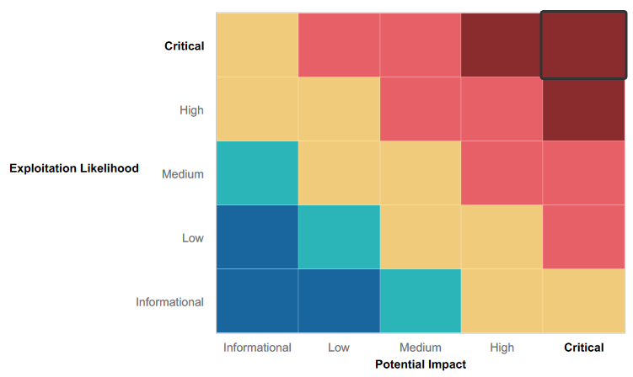

## 

### Summary of Strengths

While the assessment team was successful in finding several vulnerabilities, the team also recognized several strengths within MegaCorpOne’s environment. These positives highlight the effective countermeasures and defenses that successfully prevented, detected, or denied an attack technique or tactic from occurring.

* The basic foundation of a successful security program is the deployment and adoption of a security awareness program. MegaCorpOne’s security awareness program is already showing a measure of success in its recent implementation. All attempts to compromise the company's security via social engineering failed. Each time we were either referred to management or outright denied the requested information.
* Physical security was another obvious strength of the company. Each employee has an assigned perimeter access badge with their picture. The badge must be presented upon entry to the main building. If the employee does not have their badge then they must present an alternate form of identification to the security desk to confirm their identity and gain entry. Additionally employees must use their security badge during before and after hours. The employee must show their badge to the security guard during regular business hours. This method is crucial to avoiding “piggybacking” of employees or authorized visitors to the building.
* Reconnaissance of wireless networks resulted in only a public facing wireless SSID. In order to connect to the wireless network a user account is required to gain access. It’s likely that the SSID of the internal network is not being broadcast to prevent visibility of anyone external of the company.

### Summary of Weaknesses

CG successfully found several critical vulnerabilities that should be immediately addressed in order to prevent an adversary from compromising the network. These findings are not specific to a software version but are more general and systemic vulnerabilities.

* Contact details of senior management is readily available to the public. Best practice would be to have a centralized point of contact, whether that is a single person or departments contact details.
* Network scanning/ mapping showed no resistance. Due to this it wasn’t difficult to develop a visualization of the network infrastructure.
* During the reconnaissance phase several known vulnerabilities including open ports were identified and then exploited during the engagement.
* Login credentials were found stored within various text files and labeled as such making it obvious. These credentials lacked any complexity which in turn took little effort in cracking.

# 

## Executive Summary

A thorough security assessment of MegaCorpOne was carried out by CyberGrunt, LLC to identify vulnerabilities and security risks within their approved network infrastructure, as per the agreed scope of work. This assessment utilized penetration testing techniques to provide MegaCorpOne’s management with an understanding of the risks and security posture of the current corporate environment.

To test the security of the internal network infrastructure, reconnaissance and host discovery were used. Zenmap and the OSINT tools were used to fingerprint the operating systems, software, and services running on each target host. The various targets, open ports, and services that were enabled on each host were identified and listed, followed by vulnerability enumeration to list all potential vulnerabilities affecting each host and develop a list of viable attack vectors. Many vulnerabilities were discovered within the target host’s environment, and these vulnerabilities were exploited, compromising the confidentiality, integrity, and availability of MegaCorpOne’s resources.

The vulnerability testing identified a range of Critical, High, and Medium severity issues affecting MegaCorpOne’s internal network, which require immediate remediation efforts to secure the company’s environment against malicious threat actors. Based on the overall assessment of MegaCorpOne, it appears that the company is not adequately prepared to defend against a current attack and should take immediate steps to address the findings presented in this report.

## Summary Vulnerability Overview

| **Vulnerability** | **Severity** |
| --- | --- |
| Weak password on public web application | **Critical** |
| Exploiting and Privilege Escalation | **Critical** |
| Password Cracking | **Critical** |
| LLMNR Spoofing Vulnerability | **Critical** |
| Setting up Penitence on Compromised Machine | **Critical** |
| Site Profile from Shodan.io and Known Exploits | **Critical** |
| Privilege Escalation Exploit & Persistence | **Critical** |
| Vulnerable Open Ports on the Network | **Critical** |
| Credential Dumping & Lateral Movement | **High** |
| Reverse Shell Vulnerability | **High** |
| Windows Open Port | **High** |
| Executive Team’s Business Contact Information on Company Site | **Medium** |
| Server Details and Robots.txt file Configuration | **Low** |

The following summary tables represent an overview of the assessment findings for this penetration test:

| **Scan Type** | **Total** |
| --- | --- |
| Hosts | 172.22.117.20  172.22.117.150 |
| Ports | 172.22.117.20  135 - msrpc  139 - netbios-ssn  445 - Microsoft-ds  3390 - ms-wbt-server  172.22.117.150  21 - ftp  22 - ssh  23 - telnet  25 - smtp  53 - domain  80 - http  111 - rpcbind |

| **Exploitation Risk** | **Total** |
| --- | --- |
| **Critical** | 8 |
| **High** | 3 |
| **Medium** | 1 |
| **Low** | 1 |

## Vulnerability Findings

### Weak Password on Public Web Application

**Risk Rating**: **Critical**

**Description**:

The site **vpn.megacorpone.com** is used to host the Cisco AnyConnect configuration file for MegaCorpOne. This site is secured with basic authentication but is susceptible to a dictionary attack. Our team was able to use a username gathered from OSINT in combination with a wordlist in order to guess the user’s password and access the configuration file.

**Affected Hosts**: vpn.megacorpone.com

**Remediation**:

* Set up two-factor authentication instead of basic authentication to prevent dictionary attacks from being successful.
* Require a strong password complexity that requires passwords to be over 12 characters long, upper+lower case, & include a special character.
* Reset the user **thudson** password.

**Executive Team Business Contact Information on Company Website**

**Risk Rating**: Medium

**Description:** The [www.megacorpone.com](http://www.megacorpone.com) URL (referred to as URL) provided details about the executive team, including their full names, titles, email addresses, and images. CG utilized the Google Dorking OSINT approach to gather this information on the executive team members, as shown in Figures 1 and 2. Furthermore, the web server is operating on a Debian distro with Apache 2.4.38 on port 80, as depicted in Figure 3. While this information alone may not present a security concern, it can become a potential security risk when combined with other information. Malicious threat actors often collect information over a prolonged period of time to build victim profiles and carry out attacks.

**Affected Hosts**: [www.megacorpone.com](http://www.megacorpone.com)

**Remediation:**

* Remove direct contact information of the executive team from the website.
* Use a single email address where all public communication is received and routed accordingly, ie: [contactus@megacorpone.com](mailto:contactus@megacorpone.com), or info@megacorpone.com

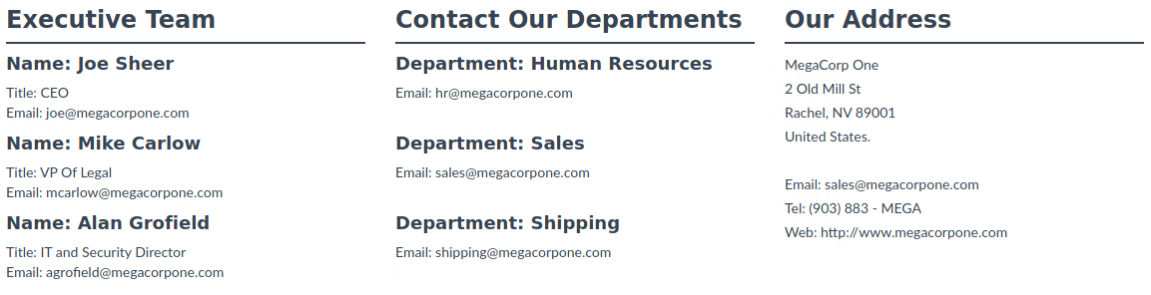

**Figure 1. Executive Team contact information.**



**Figure 2. Executive Team images and names.**

**Server Details and Robots.txt File Configuration**

**Risk Rating**: Low

**Description:** As shown in Figure 3, the URL indicated that the web server is hosted on a Debian distro with Apache 2.4.38 on port 80. Moreover, the backend server revealed the presence of a “robots.txt” file. This configuration allows web crawlers unrestricted access to the megacorpone website, enabling them to map its structure in its entirety (as illustrated in Figure 4). This level of access also permits malicious actors to identify the technologies being used and document any known vulnerabilities that can be exploited later.

**Remediation:** The robots.txt file should be configured to exclude specific areas of the site (User-agent:*- Disallow /include/).

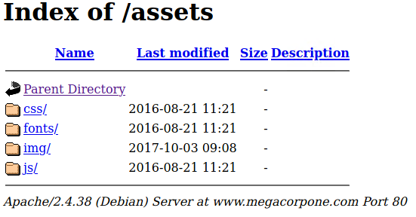

Figure 3. OS/ server Version and port

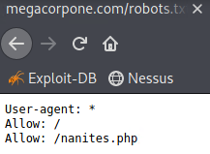

Figure 4. Robots.txt with no crawling restrictions.

**Site Profile from Shodan.io and Known Exploits**

**Risk Rating**: **Critical**

**Description**: By performing a basic “nslookup” of the domain [www.megacorpone.com](http://www.megacorpone.com) from my workstation (as illustrated in Figure 5), we were able to obtain the external facing IP address. This IP address was then used to locate the site’s profile and all associated details on [www.shodan.io](http://www.shodan.io), as demonstrated in Figure 6.

The following is Shodan.io profile of the company’s site:

**Site Profile:**

1. Open Ports:
   1. SSH-22
   2. HTTP-80
   3. HTTPS-443
2. SSH: Open SSH 7.9p1 Debian - SSH-2.0-OpenSSH_7.9p1 Debian-10+deb10u2
3. Operating System: Debian-10+deb10u2
4. Web Server: Apache 2.4.38
5. Server Location: Montreal, Canada

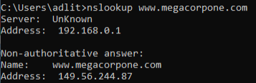

Figure 5. Command Prompt to obtain external IP address.

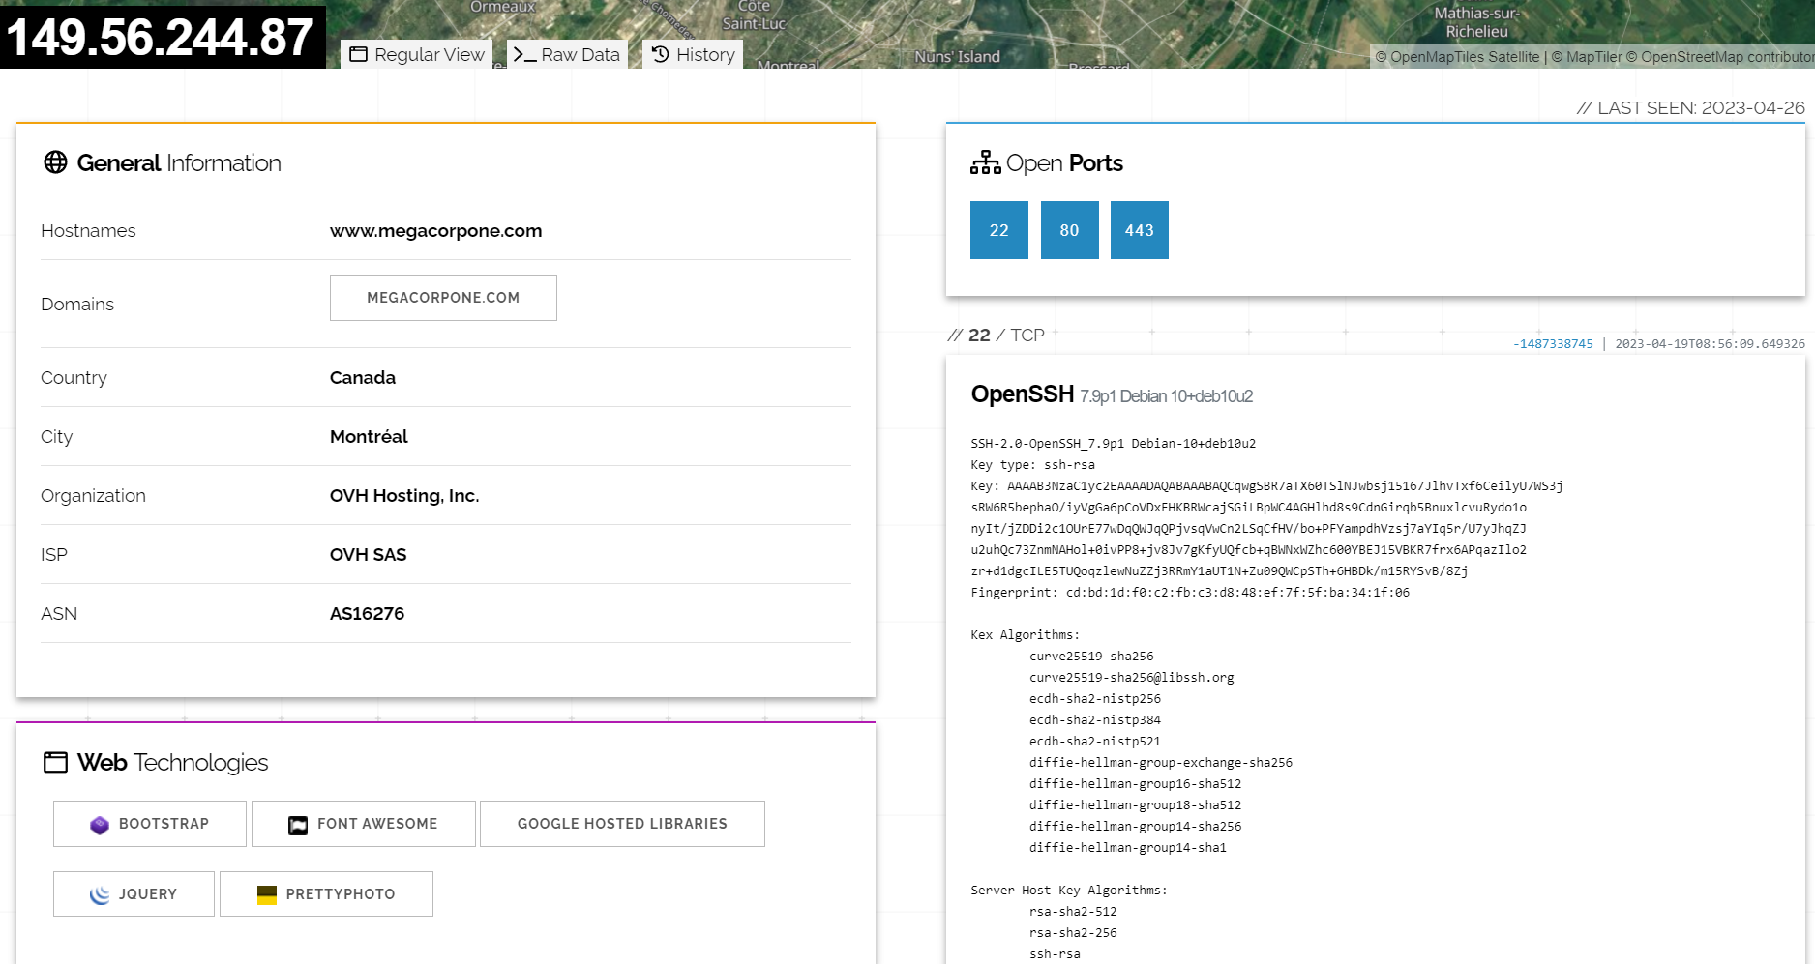

Figure 6. Shodan.io profile.

**Known CVE Vulnerabilities:**

Note: The device may not be impacted by all these issues. The vulnerabilities are implied based on the software and version.

**CVE-2019-0215** In Apache HTTP Server 2.4 releases 2.4.37 and 2.4.38, a bug in mod_ssl when using per-location client certificate verification with TLSv1.3 allowed a client to bypass configured access control restrictions.

**CVE-2020-1934** In Apache HTTP Server 2.4.0 to 2.4.41, mod_proxy_ftp may use uninitialized memory when proxying to a malicious FTP server.

**CVE-2021-34798** Malformed requests may cause the server to dereference a NULL pointer. This issue affects Apache HTTP Server 2.4.48 and earlier.

**CVE-2020-35452** Apache HTTP Server versions 2.4.0 to 2.4.46 A specially crafted Digest nonce can cause a stack overflow in mod_auth_digest. There is no report of this overflow being exploitable, nor the Apache HTTP Server team could create one, though some particular compiler and/or compilation option might make it possible, with limited consequences anyway due to the size (a single byte) and the value (zero byte) of the overflow.

**CVE-2022-29404** In Apache HTTP Server 2.4.53 and earlier, a malicious request to a lua script that calls r:paETNebody(0) may cause a denial of service due to no default limit on possible input size.

**CVE-2019-0211** In Apache HTTP Server 2.4 releases 2.4.17 to 2.4.38, with MPM event, worker or prefork, code executing in less-privileged child processes or threads (including scripts executed by an in-process scripting interpreter) could execute arbitrary code with the privileges of the parent process (usually root) by manipulating the scoreboard. Non-Unix systems are not affected.

**CVE-2022-28330** Apache HTTP Server 2.4.53 and earlier on Windows may read beyond bounds when configured to process requests with the mod_isapi module.

**CVE-2020-11993** Apache HTTP Server versions 2.4.20 to 2.4.43 When trace/debug was enabled for the HTTP/2 module and on certain traffic edge patterns, logging statements were made on the wrong connection, causing concurrent use of memory pools. Configuring the LogLevel of mod_http2 above "info" will mitigate this vulnerability for unpatched server.

**CVE-2019-10081** HTTP/2 (2.4.20 through 2.4.39) very early pushes, for example configured with "H2PushResouETNe", could lead to an overwrite of memory in the pushing request's pool, leading to crashes. The memory copied is that of the configured push link header values, not data supplied by the client.

**CVE-2019-0217** In Apache HTTP Server 2.4 release 2.4.38 and prior, a race condition in mod_auth_digest when running in a threaded server could allow a user with valid credentials to authenticate using another username, bypassing configured access control restrictions.

**CVE-2019-0197** A vulnerability was found in Apache HTTP Server 2.4.34 to 2.4.38. When HTTP/2 was enabled for a http: host or H2Upgrade was enabled for h2 on a https: host, an Upgrade request from http/1.1 to http/2 that was not the first request on a connection could lead to a misconfiguration and crash. Server that never enabled the h2 protocol or that only enabled it for https: and did not set "H2Upgrade on" are unaffected by this issue.

**CVE-2019-0196** A vulnerability was found in Apache HTTP Server 2.4.17 to 2.4.38. Using fuzzed network input, the http/2 request handling could be made to access freed memory in string comparison when determining the method of a request and thus process the request incorrectly.

**CVE-2022-22721** If LimitXMLRequestBody is set to allow request bodies larger than 350MB (defaults to 1M) on 32 bit systems an integer overflow happens which later causes out of bounds writes. This issue affects Apache HTTP Server 2.4.52 and earlier.

**CVE-2022-22720** Apache HTTP Server 2.4.52 and earlier fails to close inbound connection when errors are encountered discarding the request body, exposing the server to HTTP Request Smuggling.

**CVE-2019-10092** In Apache HTTP Server 2.4.0-2.4.39, a limited cross-site scripting issue was reported affecting the mod_proxy error page. An attacker could cause the link on the error page to be malformed and instead point to a page of their choice. This would only be exploitable where a server was set up with proxying enabled but was misconfigured in such a way that the Proxy Error page was displayed.

**CVE-2019-17567** Apache HTTP Server version 2.4.6 to 2.4.46 mod_proxy_wstunnel configured on an URL that is not necessarily Upgraded by the origin server was tunneling the whole connection regardless, thus allowing for subsequent requests on the same connection to pass through with no HTTP validation, authentication or authorization possibly configured.

**CVE-2019-10097** In Apache HTTP Server 2.4.32-2.4.39, when mod_remoteip was configured to use a trusted intermediary proxy server using the "PROXY" protocol, a specially crafted PROXY header could trigger a stack buffer overflow or NULL pointer deference. This vulnerability could only be triggered by a trusted proxy and not by untrusted HTTP clients.

**CVE-2022-31813** Apache HTTP Server 2.4.53 and earlier may not send the X-Forwarded-* headers to the origin server based on client side Connection header hop-by-hop mechanism. This may be used to bypass IP based authentication on the origin server/application.

**CVE-2019-10098** In Apache HTTP server 2.4.0 to 2.4.39, Redirects configured with mod_rewrite that were intended to be self-referential might be fooled by encoded newlines and redirect instead to an unexpected URL within the request URL.

**CVE-2021-40438** A crafted request uri-path can cause mod_proxy to forward the request to an origin server chosen by the remote user. This issue affects Apache HTTP Server 2.4.48 and earlier.

**CVE-2021-36160** A carefully crafted request uri-path can cause mod_proxy_uwsgi to read above the allocated memory and crash (DoS). This issue affects Apache HTTP Server versions 2.4.30 to 2.4.48 (inclusive).

**CVE-2022-23943** Out-of-bounds Write vulnerability in mod_sed of Apache HTTP Server allows an attacker to overwrite heap memory with possibly attacker provided data. This issue affects Apache HTTP Server 2.4 version 2.4.52 and prior versions.

**CVE-2020-1927** In Apache HTTP Server 2.4.0 to 2.4.41, redirects configured with mod_rewrite that were intended to be self-referential might be fooled by encoded newlines and redirect instead to an unexpected URL within the request URL.

**CVE-2022-30522** If Apache HTTP Server 2.4.53 is configured to do transformations with mod_sed in contexts where the input to mod_sed may be very large, mod_sed may make excessively large memory allocations and trigger an abort.

**CVE-2019-0220** A vulnerability was found in Apache HTTP Server 2.4.0 to 2.4.38. When the path component of a request URL contains multiple consecutive slashes ('/'), directives such as LocationMatch and RewriteRule must account for duplicates in regular expressions while other aspects of the servers processing will implicitly collapse them.

**CVE-2020-9490** Apache HTTP Server versions 2.4.20 to 2.4.43. A specially crafted value for the 'Cache-Digest' header in a HTTP/2 request would result in a crash when the server actually tries to HTTP/2 PUSH a resource afterwards. Configuring the HTTP/2 feature via "H2Push off" will mitigate this vulnerability for unpatched server.

**CVE-2020-11984** Apache HTTP server 2.4.32 to 2.4.44 mod_proxy_uwsgi info disclosure and possible ETNE.

**CVE-2021-44790** A carefully crafted request body can cause a buffer overflow in the mod_lua multipart parser (r:parsebody() called from Lua scripts). The Apache httpd team is not aware of an exploit for the vulnerabilty though it might be possible to craft one. This issue affects Apache HTTP Server 2.4.51 and earlier.

**CVE-2021-26690** Apache HTTP Server versions 2.4.0 to 2.4.46 A specially crafted Cookie header handled by mod_session can cause a NULL pointer dereference and crash, leading to a possible Denial Of Service.

**CVE-2021-26691** In Apache HTTP Server versions 2.4.0 to 2.4.46 a specially crafted SessionHeader sent by an origin server could cause a heap overflow.

**CVE-2022-26377** Inconsistent Interpretation of HTTP Requests ('HTTP Request Smuggling') vulnerability in mod_proxy_ajp of Apache HTTP Server allows an attacker to smuggle requests to the AJP server it forwards requests to. This issue affects Apache HTTP Server Apache HTTP Server 2.4 versions 2.4.53 and prior versions.

**CVE-2022-28614** The ap_rwrite() function in Apache HTTP Server 2.4.53 and earlier may read unintended memory if an attacker can cause the server to reflect very large input using ap_rwrite() or ap_rputs(), such as with mod_luas r:puts() function. Modules compiled and distributed separately from Apache HTTP Server that use the 'ap_rputs' function and may pass it a very large (INT_MAX or larger) string must be compiled against current headers to resolve the issue.

**CVE-2020-13938** Apache HTTP Server versions 2.4.0 to 2.4.46 Unprivileged local user can stop httpd on Windows.

**CVE-2019-10082** In Apache HTTP Server 2.4.18-2.4.39, using fuzzed network input, the http/2 session handling could be made to read memory after being freed, during connection shutdown.

**CVE-2021-44224** A crafted URI sent to httpd configured as a forward proxy (ProxyRequests on) can cause a crash (NULL pointer dereference) or, for configurations mixing forward and reverse proxy declarations, can allow for requests to be directed to a declared Unix Domain Socket endpoint (Server Side Request Forgery). This issue affects Apache HTTP Server 2.4.7 up to 2.4.51 (included).

**CVE-2022-22719** A carefully crafted request body can cause a read to a random memory area which could cause the process to crash. This issue affects Apache HTTP Server 2.4.52 and earlier.

**CVE-2022-28615** Apache HTTP Server 2.4.53 and earlier may crash or disclose information due to a read beyond bounds in ap_strsmp_match() when provided with an extremely large input buffer. While no code distributed with the server can be coersed into such a call, third-party modules or lua scripts that use ap_strsmp_match() may hypothetically be affected.

**CVE-2022-30556** Apache HTTP Server 2.4.53 and earlier may return lengths to applications calling r:wsread() that point past the end of the storage allocated for the buffer.

**CVE-2021-39275** ap_escape_quotes() may write beyond the end of a buffer when given malicious input. No included modules pass untrusted data to these functions, but third-party/external modules may. This issue affects Apache HTTP server version 2.4.48 and earlier.

Shodan.io and recon-ng were configured for sensitive information gathering by finding files such as robots.txt, Geo-IP, Banner Grabbing, DNS Lookup, port scanning, and sub-domain information. (Fig. 7,8).

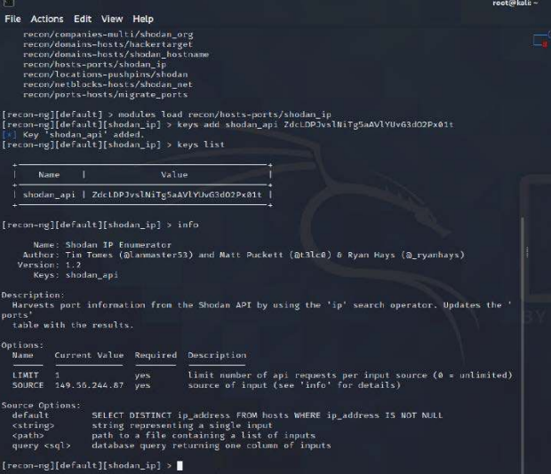

Figure 7. Recon-ng with Shodan.io API configuration

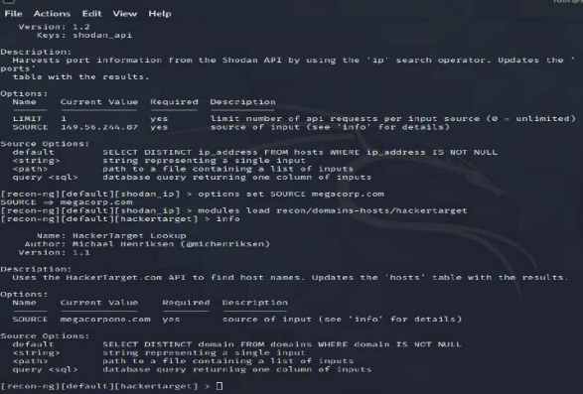

Figure8, Recon-ng scan all sub-domains and folders.

Scanning the IP address revealed several sub-domains and IP addresses, (Fig.9). CG generated reports for export and further analysis (Fig.10-12).

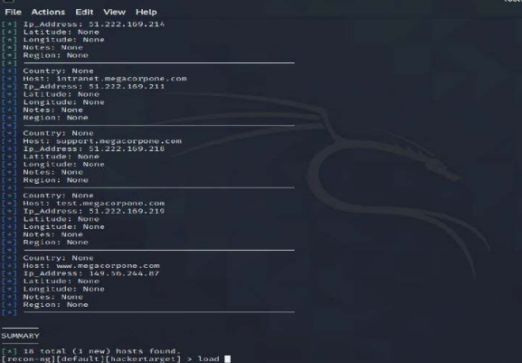

Figure 9. Recon-ng scan details

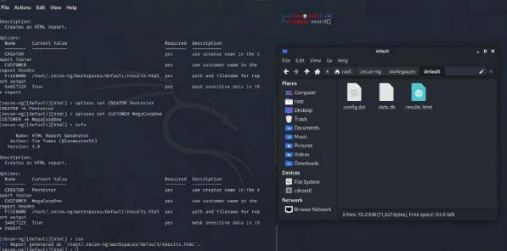

Figure 10. Root folder report

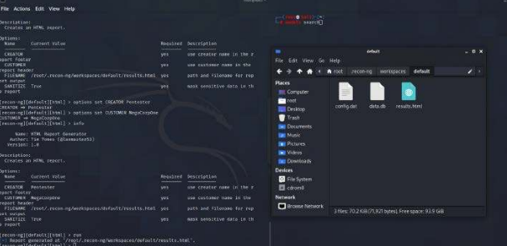

Figure 11. Pentester machine report

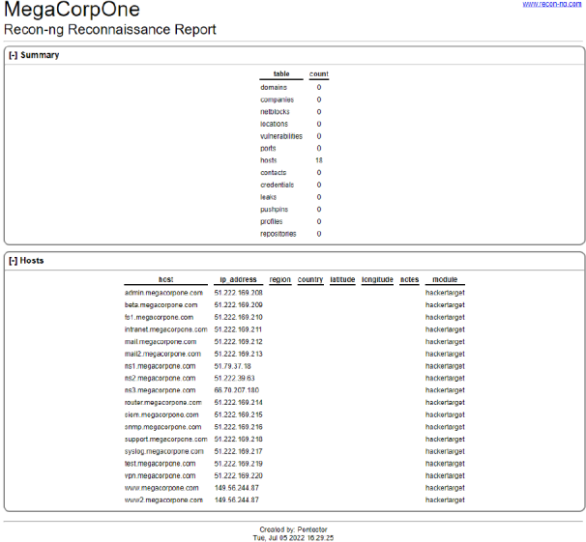

Figure 12. Recon-ng Reconnaissance Report

### Vulnerable Open Ports on The Network

**Risk Rating**: **Critical**

**Description**: Figures 13 through 16, obtained from a Zenmap scan, provided a list of workstations with open ports running potentially vulnerable applications. Subsequent analysis confirmed the existence of a potential known exploit (Figure 15), specifically **“21/tcp open ftp vsftpd”.** Using Searchsploit, we identified seven (7) known exploits (Figure 17), including **“vsftpd 2.3.4 - Backdoor Command Execution Unix/remote/49757.py”.** We reviewed this exploit (Figure 18) to determine the necessary parameters and arguments required for successful execution. As a result, CG gained entry into the workstation with the IP address **172.22.117.150** and was able to access a shell (Figure 19). The command “whoami” confirmed that we had achieved “root” access to the workstation. We have included additional resources regarding this exploit in Figure 20.

**Affected Hosts:** megacorpone.com

**Remediation:**

* Perform regular vulnerability scanning for network visibility.
* Subscribe to various services that provide the latest CVE updates.
* Verify the current software is patched or replaced if necessary to maintain security.
* Close all unnecessary ports and set access rules to govern usage.

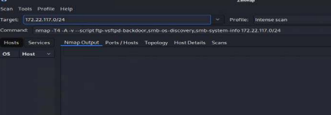

Figure 13. Zenmap Vulnerability scan.

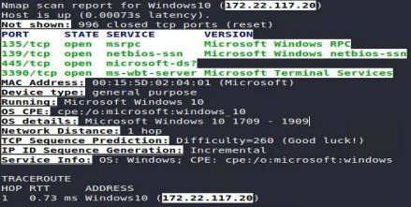

Figure 14. Scan results for 172.22.117.20.

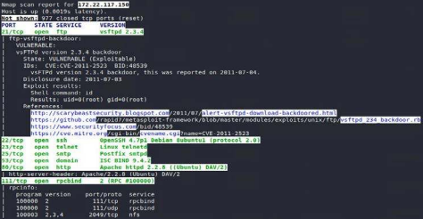

Figure 15. Scan results for 172.22.117.150.

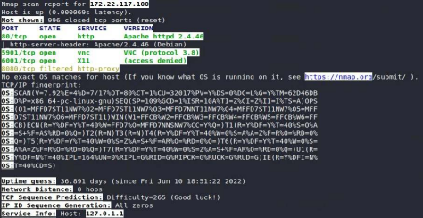

Figure 16. Scan results for 172.22.117.100.

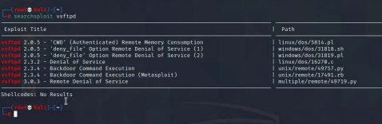

Figure 17. Searchsploit results for the vsftpd exploit.

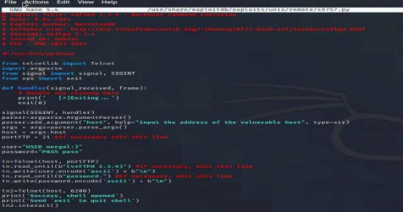

Figure 18. Exploitation script.

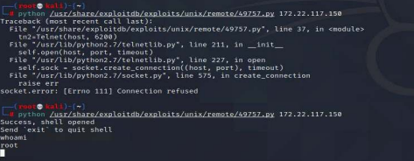

Figure 19. Executed python exploit against 172.22.117.150.

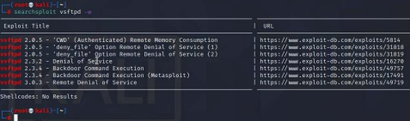

Figure 20. Searchsploit vsftpd exploit.

### Exploiting and Privilege Escalation

**Risk Rating**: **Critical**

**Description**: During the initial phase of the project, the team discovered weak password management practices. The CG team utilized the shell exploit to search for all files and folders containing the phrase “pass” by executing the command **“find / -type f -iname “pass.txt ""** as shown in Figure 21. This search led to the discovery of the file **“/var/tmp/adminpassword.txt”**, which was believed to contain login credentials, as shown in Figures 22 and 23. The CG team utilized these credentials to establish an SSH connection to 172.22.117.150 using the command **“ssh msfadmin@172.22.117.150”** and were able to escalate privileges to a “root” shell, as depicted in Figures 24 and 25.

**Affected Hosts:** megacorpone.com

**Remediation:**

* Use an approved enterprise tool for password management.
* Create a whitelist of users and computers allowed to SSH into the server.
* Do not save files and folders on the computer with login credentials.

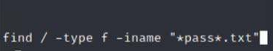

Figure 21. Locate any file with “pass” command.

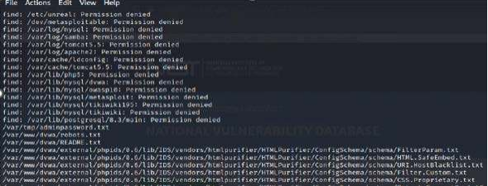

Figure 22. Potential identified passwords.

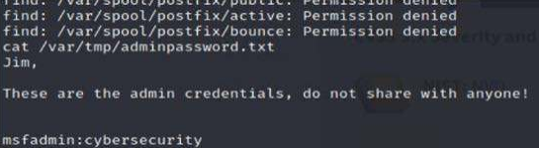

Figure 23. File contents using cat command.

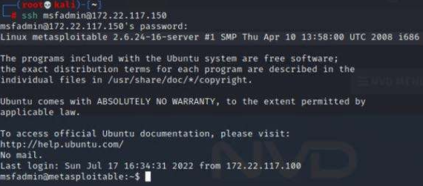

Figure 24.

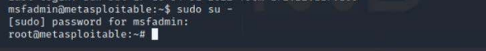

Figure 25.

### Password Cracking

**Risk Rating**: **Critical**

**Description**: CG gained access to the machine through a “root” shell (Figure 26), and performed a search for the shadow file by executing the command **“sudo cat /etc/shadow”** which was then displayed on the screen (Figure 27). After obtaining the user accounts, CG created a new file named “shadowfile.txt” containing valid credentials (Figure 28). Using the “John the Ripper” password cracking tool (Figure 29), CG attempted to crack the passwords in the file. Although the first attempt was unsuccessful, the second attempt was successful when the extracted list was matched against **“rockyou.txt”**, allowing all passwords to be cracked (Figure 30). The new login credentials obtained will be used in subsequent activities.

**Affected Hosts:** megacorpone.com

**Remediation:**

* Avoid frequently used words such as password, admin, 123456, etc…
* Passwords should consist of a combination of alphanumeric characters (both upper and lower case), numbers, and include special characters if the software allows.
* Do not reuse passwords to include using the same password across multiple services (email, social media, etc…). The password list used in “John the Ripper” is a combination of compromised online credentials.
* Security awareness training to improve the tech acumen of its employees.

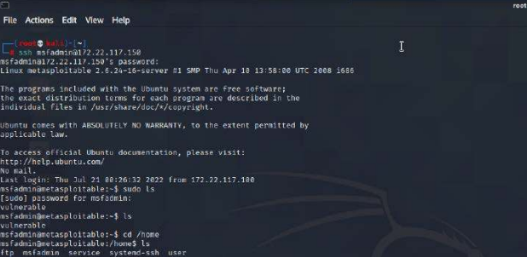

Figure 26. SSH access to compromise systems.

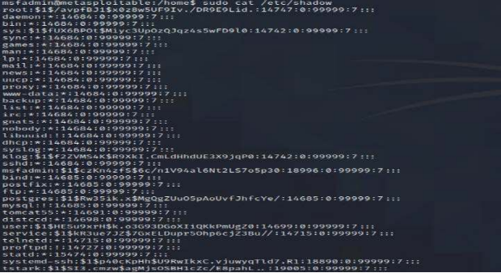

Figure 27. Unedited etc/shadow/ file.

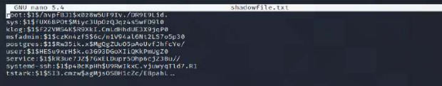

Figure 28. Sanitized file for all users and hashed passwords.

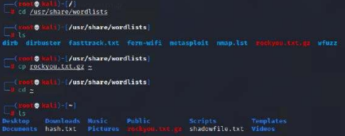

Figure 29. “John the Ripper” directory.

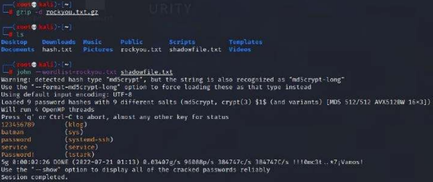

Figure 30. Cracked copy of the shadow file.

### Setting Up Persistence on the Compromised Machine

# 

**Risk Rating**: **Critical**

# Description: CG established an SSH connection to the compromised system with the intention of camouflaging an intruder’s activity by creating a new user with root access privileges. After logging back into the system, a new account named “systemd1-ssh” was created (Figure 31, 32). This new account eliminates the need for brute force attacks or password cracking to gain access to the system. CG was able to access the system successfully as a legitimate user (Figure 33). With this access, an intruder could move throughout the company’s network without attracting much attention.

# 

# Affected Hosts: megacorpone.com

**Remediation:**

* Perform vulnerability assessments to determine accounts that can be compromised.
* Deploy a privilege access management system to manage accounts with elevated privileges.
* Configure strict user access policies that will prevent users from using machines that are not in their department.
* Enable account creation and deletion logs, which are audited at regular intervals.

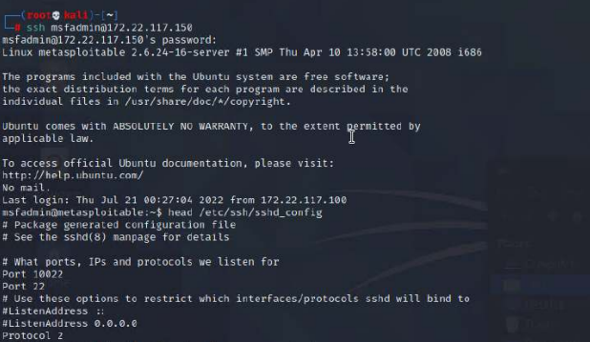

Figure 31. SSH into a compromised system.

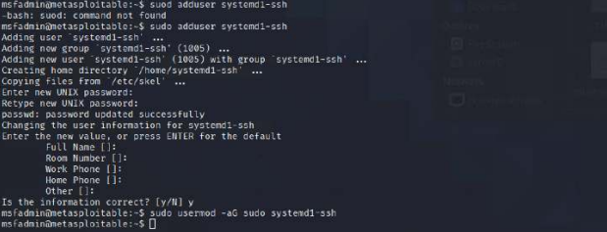

Figure 32. Account creation with elevated privileges to access the system.

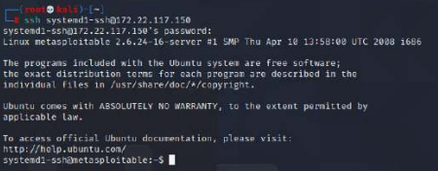

Figure 33. New account creation confirmation.

### Windows Open Port

**Risk Rating**: **High**

# Description: During the reconnaissance phase, CG found that the environment consists of two types of operating systems: Linux and Windows. The team focused on identifying and exploiting vulnerabilities within the Windows environment. An initial scan detected two Windows machines with open ports and their respective IP addresses were identified (Figure 34, 35). One of the machines, the Domain Controller (DC), was found to be running Kerberos authentication protocol on port 88, making it easily identifiable. The two systems had a total of fifteen (15) open ports, making them potential attack vectors for threat actors to gain unauthorized access to the system or network.

**Affected Hosts:** megacorpone.com

**Remediation:**

* Close all unnecessary/unused ports
* Regularly patch all operating systems for security.
* Ensure firewall rules are in place to screen traffic to the network and DC.

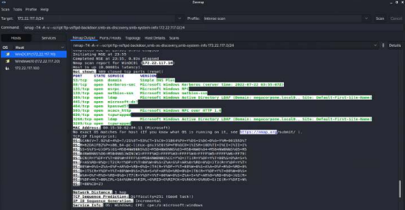

Figure 34. Domain Controller for network.

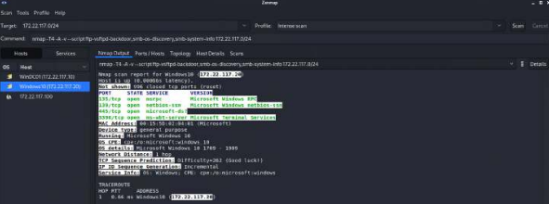

Figure 35. Second Windows Machine in the network.

### Vulnerability to Password Spraying

**Risk Rating**: **Medium**

# Description: The technique of Password Spraying involves using a set of login credentials to attempt unauthorized access on multiple systems. In the initial stage of the engagement, CG employed “John the Ripper” to crack a password file and gained access to several login credentials. Subsequently, CG utilized Metasploit in combination with “auxiliary/scanner/smb/smb_login” and configured the options (as shown in Figure 36, 37) to launch the password spraying attack. The attack was successful in identifying the system (as depicted in Figure 38). Further, the relevant system linked to the network credentials was identified.

**Affected Hosts:** megacorpone.com

**Remediation:**

* Set a maximum password login attempt after which the account will be locked out for a period.
* Change the default passwords for all system and web applications.
* Implement measures to detect bot activity.

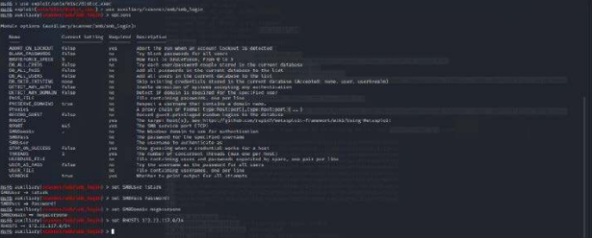

Figure 36. Metasploit exploit to login to system.

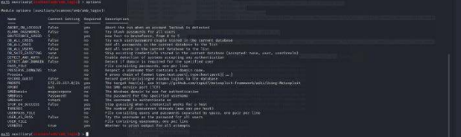

Figure 37. Options to narrow attack.

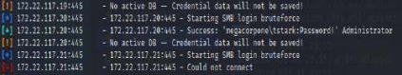

Figure 38. Successful logon credentials.

### LLMNR Spoofing Vulnerability

**Risk Rating**: **Critical**

# Description: The engagement involved exploiting the vulnerability of LLMNR protocol to capture password hashes from networked systems. CG set up a listener to spoof password hashes as systems attempted to authenticate. The attack was successful in capturing the Client, Username, and Password hash (Figure 39). The password hash was then saved to a text file and cracked using the “John the Ripper” tool (Figure 40). As a result, our team was able to obtain additional login credentials (username: pparker - password: Spring2021) for future access. This technique of LLMNR spoofing provides a way for attackers to harvest valid login credentials from unsuspecting network users.

**Affected Hosts:** megacorpone.com

**Remediation:**

* Disable the LLMNR service

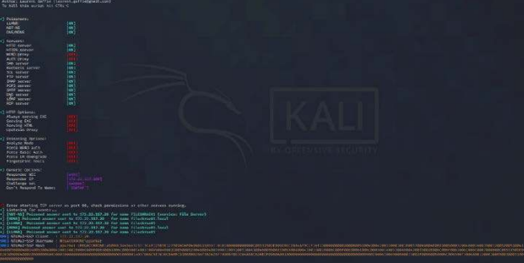

Figure 39. Listener deployed on the network waiting to initiate authentication.

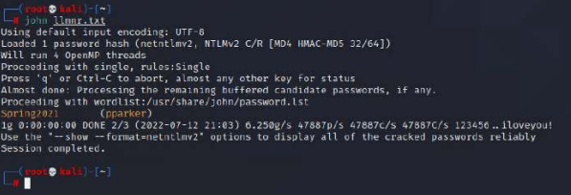

Figure 40. Listener captured credential and placed in text file to be cracked by John the Ripper.

### Windows Management Instrumentation (WMI) Vulnerability

**Risk Rating**: **Medium**

# Description: The Windows Management Instrumentation (WMI) is an administrative tool in Windows, but it can also be exploited by attackers for information gathering. CG used Metasploit and the exploit “auxiliary/scanner/smb/impacket/wmiexec” to retrieve the current running process (Figure 41, 42). This allowed access to sensitive system and network data, such as those shown in Figure 43-45. By obtaining this information, attackers can modify systems, achieve persistence, move laterally, and remain undetected.

**Affected Hosts:** megacorpone.com

**Remediation:**

* Deploy anti-malware systems to detect the use of powershells.
* Additional tools to monitor and detect specific activities on the network.

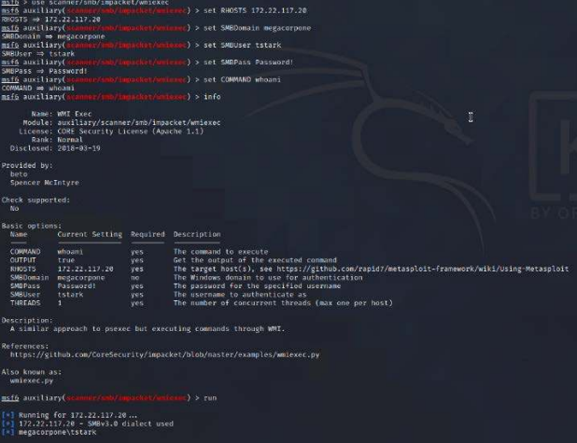

Figure 41. Metasploit exploit to gain access.

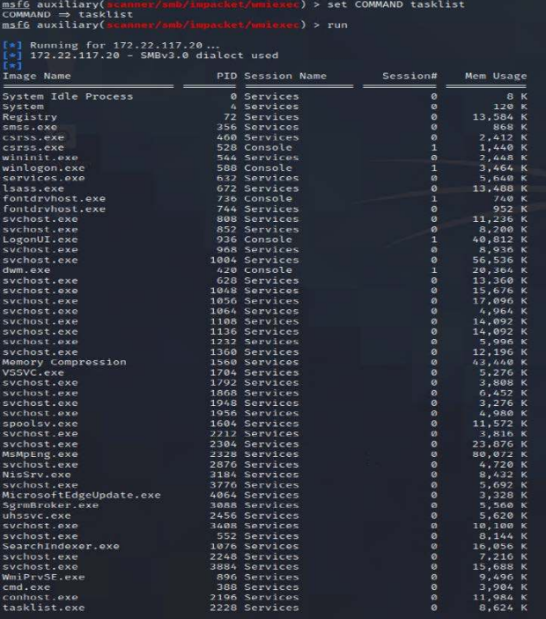

Figure 42. List of all WMI processes currently running.

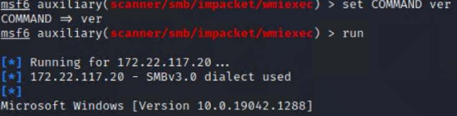

Figure 43. Windows version.

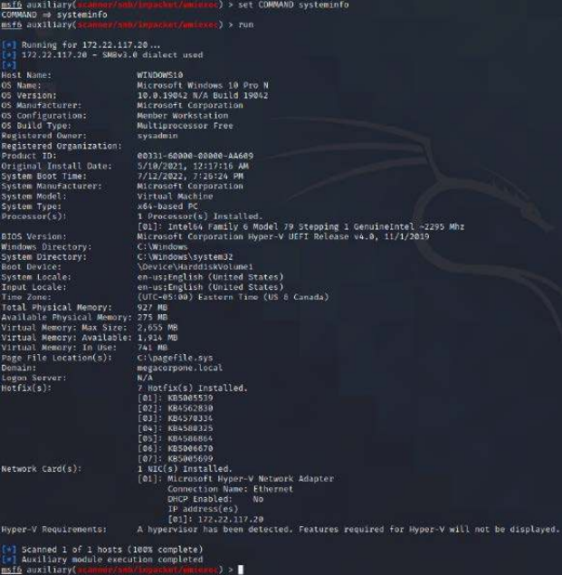

Figure 44. Windows system information.

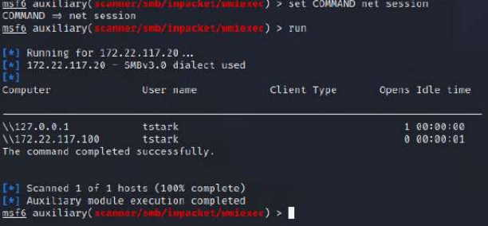

Figure 45. Windows net session information.

### Reverse Shell Vulnerability

**Risk Rating**: **High**

# Description: The Reverse Shell is an important tool that allows the attacker to establish communication and gain complete control of the target machine by opening ports, thus bypassing some firewalls. To initiate the listener port for the reverse shell, CG used “msfvenom”, as shown in (Figure 46). Using the exploit “exploit/multi/handler/” and payload “windows/meterpreter/reverse_tcp”, CG created a reverse shell on Port 4444 with Metasploit, thereby establishing a “meterpreter” session, as seen in (Figure 47,48).

**Affected Hosts:** megacorpone.com

**Remediation:**

* Lock all outgoing connectivity except for specific ports and remote IP addresses needed for required services.
* Configure a proxy server as an intermediary between the external IP address and internal network.
* Remove any unnecessary services, restricting the execution of reverse shell code.
* Perform scheduled patching of the web applications to limit potential vulnerabilities.

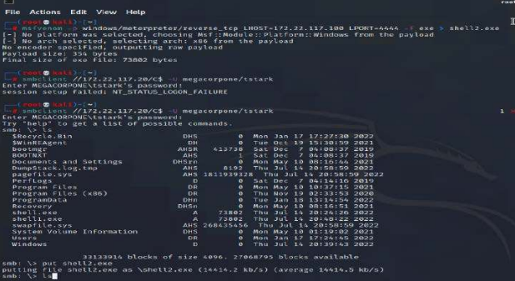

Figure 46. Listing Port configured for communication.

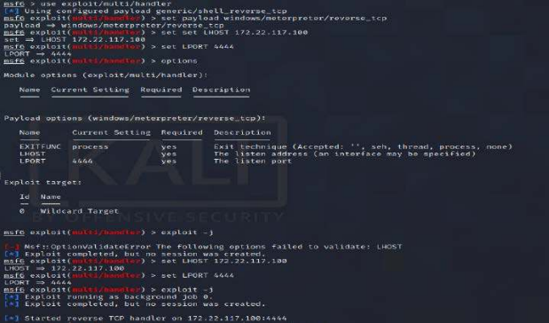

Figure 47. Exploit deployed through reverse TCP handler.

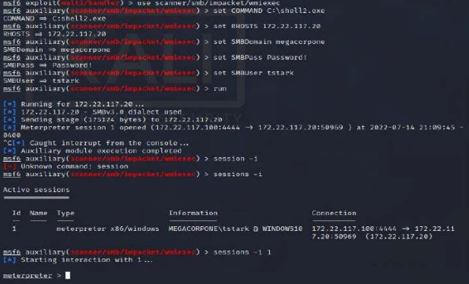

Figure 48. Meterpreter session started.

### Privilege Escalation Exploit & Persistence

**Risk Rating**: **Critical**

# Description: During the operation, CG acquired multiple login credentials, although none of them granted administrator access. In order to maintain access to the system, the previously established meterpreter session was “backgrounded” and used to execute the “exploit/windows/local/persistence_service” exploit , creating a persistent backdoor (Figure 49, 50). To conceal its true purpose, the process was then moved to an active Windows process (Figure 51, 52). This backdoor shell ensured a continuous connection and was set to automatically re-establish itself at midnight if the process was terminated (Figure 53). The danger of a persistent threat is that it can be difficult to detect an intruder’s presence, allowing for potential data exfiltration.

**Affected Hosts:** megacorpone.com

**Remediation:**

* Strong perimeter defenses
* Not sharing login credentials
* Security awareness training by teaching employees on how to identify phishing attempts.
* Promoting safe browsing habits at work.

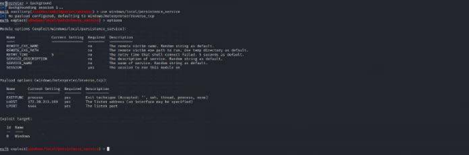

Figure 49. Establishing a meterpreter session.

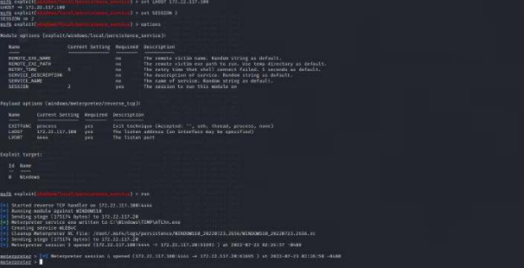

Figure 50. Meterpreter session established.

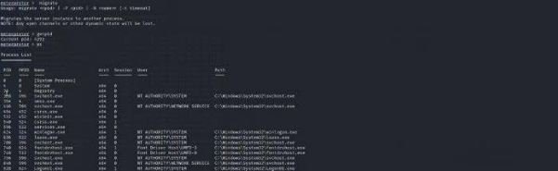

Figure 51. Process being migrated to blend with Windows processes.

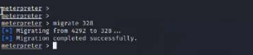

Figure 52. Successful process migration.

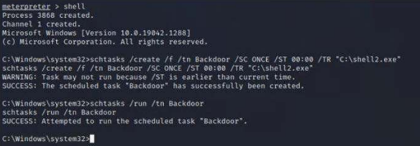

Figure 53. Persistence established.

### Credential Dumping & Lateral Movement

**Risk Rating**: **High**

# Description: In this phase of the operation, CG utilized Mimikatz Kiwi to execute the “kiwi_cmd lsadump::cache” command which resulted in the dumping of all users on the Windows Domain Controller, as seen in (Figure 54, 55). The credentials obtained were saved in “hash.txt” and the “John the Ripper” command “john –format=mscash2 hash.txt” was utilized to crack the password dor user “bbanner”, as shown in (Figure 56). This enabled lateral movement throughout the network, as shown in (Figure 57, 58). As the traffic can appear to be normal network traffic, detection will be challenging. The system has now been completely compromised, providing an attacker with the ability to move through the network.

**Affected Hosts:** megacorpone.com

**Remediation:**

* Update your Endpoint Security Solution.
* Proactively hunt for advanced threats and strengthen perimeter defenses.
* Maintain proper IT Hygiene by eliminating vulnerabilities such as outdated or unpatched systems.

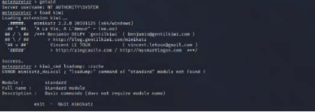

Figure 54. Kiwi loaded to initiate credential dumping.

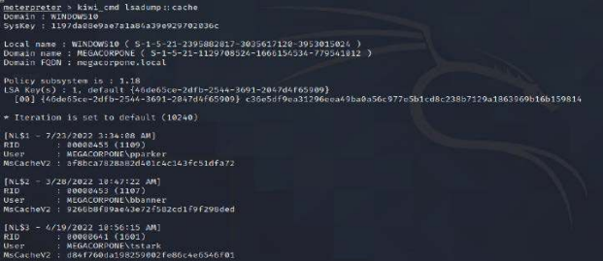

Figure 55. Cache dumping user credentials.

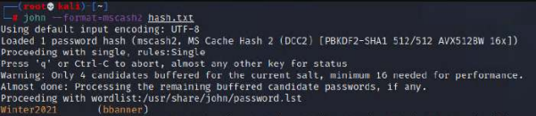

Figure 56. “bbanner” cracked credentials used for lateral movement.

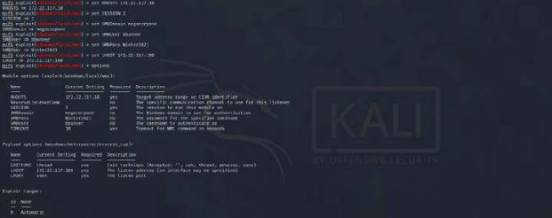

Figure 57. Meterpreter initiated for lateral movement.

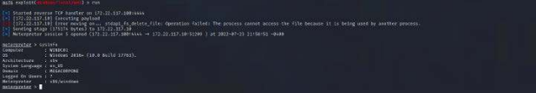

Figure 58. Operating from Windows DC.

### 

### Compromised Server Users

**Risk Rating**: **Medium**

# Description: Arriving at this final stage of the engagement via the use of a meterpreter shell, CG now has the ability to view all user accounts registered on the Domain Controller, (Figure 59, 60).

**Affected Hosts:** megacorpone.com

**Remediation:**

* Update your Endpoint Security Solution
* Proactively hunt for advanced threats and strengthen perimeter defenses.
* Maintain proper IT Hygiene by eliminating vulnerabilities such as outdated or unpatched systems.

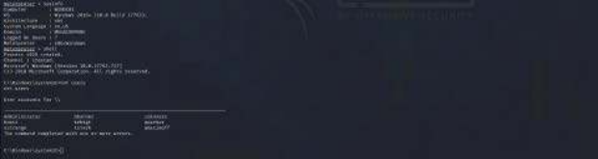

Figure 59. All users registered on the DC and accessible.

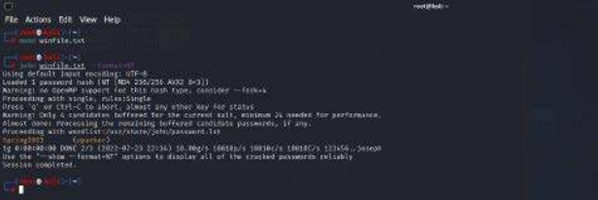

Figure 60. Final user account cracked.

# 

# 

# 

# 

## MITRE ATT&CK Navigator Map

The MITRE ATT&CK navigator map shows all the techniques and tactics that CG used throughout the assessment.

Legend: Highlighted tactics performed successfully.

